MONTHLY TEST 1: COMPUTER SCIENCE 2
Candidate Name: Prosper Lukamaja Masunga
Index Number: S4692-0625

QUESTION 1:
- Source code

#include <iostream>
#include <string>
#include <vector>
#include <iomanip>
using namespace std;

const int OVERTIME_THRESHOLD = 40;
const double TAX_RATE = 1.5 / 100.0;
string companyName = "Web Developers R Us Inc.";

class Employee {
private:
string employeeID;
string name;
double hourlyRate;
double hoursWorked;

public:
// Constructor with initializer syntax
Employee(string empID, string empName, double hrRate, double hrsWorked) :
employeeID(empID), name(empName), hourlyRate(hrRate), hoursWorked(hrsWorked) {}

double calculateGrossPay()
{
int overtimeHours;
if (getHoursWorked() > 40) {
overtimeHours = getHoursWorked() - OVERTIME_THRESHOLD;
return hourlyRate * 40 + ((hourlyRate * 1.5) * overtimeHours);
}
return hoursWorked * hourlyRate;
}

double calculateNetPay()
{
return calculateGrossPay() - TAX_RATE * calculateGrossPay();
}

// Enforce encapsulation through getter methods
string getName() {
return name;
}

string getID() {
return employeeID;
}

double getHourlyRate() {
return hourlyRate;
}

int getHoursWorked() {
return hoursWorked;
}
};

vector<Employee> employees;

void registerEmployeeData()
{
cout << "\n\n------ REGISTER EMPLOYEE DATA ------" << endl;
cout << "How many employees do you want to create? ";
int numEmployees;
cin >> numEmployees;

if (numEmployees < 1) {
cout << "You must have at least 1 employee!" << endl;
return;
}

// Loop for all N employees' data
int i = 1;
while (i <= numEmployees) {
cout << "\nInput data for employee " << i << "..." << endl;

string id, eName;
double hrRate;
int hrsWorked;
cout << "Employee ID: ";
cin >> id;
cout << "Employee name: ";
cin >> eName; // GETLINE IS OVER HEREEEE!!!

while (true) {
cout << "Hourly pay rate for " << eName << " in USD: ";
cin >> hrRate;
// Validate hourly pay rate
if (hrRate < 0) {
cout << "Hourly pay rate must be greater than zero! Try again." << endl;
continue;
}
break;
}

while (true) {
cout << "Total hours worked by " << eName << ": ";
cin >> hrsWorked;

// Validate hours worked
if ((hrsWorked < 0) || (hrsWorked > 160)) {
cout << "Hours worked must be between 0 and 160 only! Try again.\n" << endl;
continue;
}
break;
}

// Increment the counter variable
i++;

// Create an object for this employee and push it onto the vector
Employee employee(id, eName, hrRate, hrsWorked);
employees.push_back(employee);
cout << "Successfully created employee " << eName << "! \n" << endl;
}
}

double calculateTotalExpenditure()
{
double totalExpenditure;
for (int i = 0; i < employees.size(); ++i)
totalExpenditure += employees[i].calculateGrossPay();
return totalExpenditure;
}

string findHighestEarningEmployee()
{
double highestPayment = 0;
int index;
for (int i = 0; i < employees.size(); ++i) {
if (employees[i].calculateGrossPay() > highestPayment) {
highestPayment = employees[i].calculateGrossPay();
index = i;
}
}
return employees[index].getName();
}

void expenditurePerEmployee()
{
if (employees.empty()) {
cout << "No employee data! Please register employees." << endl;
return;
}
cout << "\n\n---------- COMPANY EXPENDITURE PER EMPLOYEE FOR " << companyName << "----------" << endl;
for (int i = 0; i < employees.size(); ++i)
{
cout << setw(100) << "\nEmployeeID " << employees[i].getID() << " (" << employees[i].getName() << "):" << endl
<< setw(50) << "Hourly pay rate (USD/hour): " << setw(20) << employees[i].getHourlyRate() << endl
<< setw(50) << "Total hours worked: " << setw(20) << employees[i].getHoursWorked() << endl
<< setw(50) << "Gross pay (USD): " << setw(20) << setprecision(2) << employees[i].calculateGrossPay() << endl
<< setw(50) << "Net pay (USD): " << setw(20) << setprecision(2) << employees[i].calculateNetPay() << endl;
}
}

void summaryMetrics()
{
if (employees.empty()) {
cout << "No employee data! Please register employees." << endl;
return;
}
cout << "\n\n---------- SUMMARY METRICS FOR " << companyName << " ----------" << endl;
cout << setw(50) << "**** Total company expenditure: " << setw(20) << setprecision(2) << calculateTotalExpenditure() << "USD" << endl;
cout << setw(50) << "**** Highest earning employee: " << setw(20) << findHighestEarningEmployee() << endl << endl;
}

int main()
{
// Print a single introduction message
cout << "********** WELCOME TO THE MONTHLY PAYROLL CALCULATOR PROGRAM **********" << endl;

bool running = true;
while (running) {
cout << "\nPlease select an action from below:\n"
<< "1. Register employee data\n2. Show company expenditure per employee\n"
<< "3. Display summary metrics\n4. Exit\n"
<< "\nYour choice (1 - 4): ";
int choice;
cin >> choice;

switch (choice) {
case 1: {
registerEmployeeData();
break;
}
case 2: {
expenditurePerEmployee();
break;
}
case 3: {
summaryMetrics();
break;
}
case 4: {
cout << "Exiting program..." << endl;
running = false;
break;
}
default: {
cout << "Invalid input! Try again..." << endl;
cin.get();
cin.ignore();
}
}
}

return 0;
}

- Screenshots
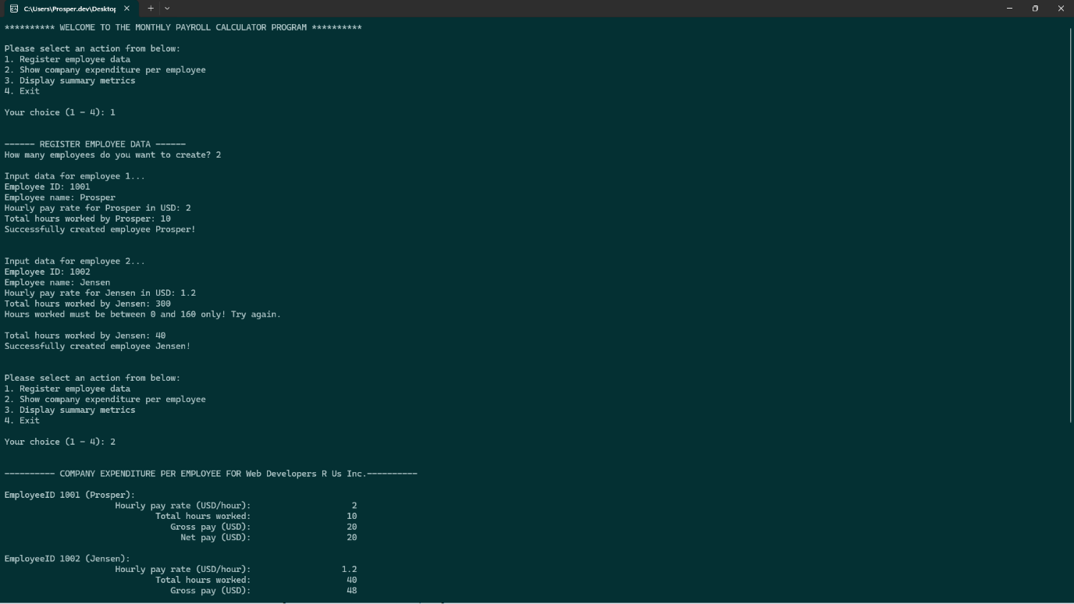
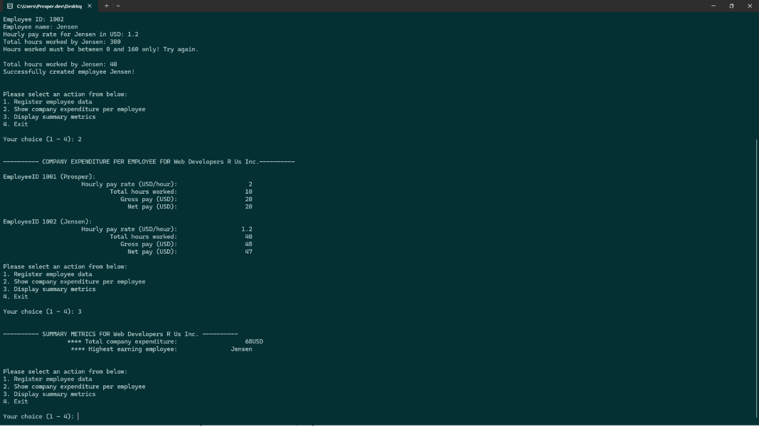

QUESTION 2:
- Source code
- """ Student Grading System """

- class Student:
- '''A class representing an actual student'''
- # Create constructor for Student object
- def __init__(self, name: str) -> None:
- self._name = name
- self._marks = [] # a list of the student's marks
- self._total = 0
- self._grade = ''
- self._average = 0

- def calculate_average(self) -> float:
- '''Calculates student's average mark'''
- for m in self._marks: self._total += m
- self._average = self._total / len(self._marks)
- return self._average

- def grade(self) -> str:
- '''Grades the student's average mark'''
- if 80 <= self._average <= 100: return "A"
- elif self._average >= 60: return "B"
- elif self._average >= 40: return "C"
- else: return "F"

- def input_marks(self) -> None:
- '''Inputs student marks for five subjects'''
- print(f"\nYou are required to input {self._name}'s marks in five subjects....")
- iterations = 0
- while iterations < 5:
- try:
- marks = float(input(f"Marks for subject {iterations + 1}: "))

- # Validate input for marks
- if marks > 100 or marks < 0:
- print("[ERROR] Marks must be between 0 - 100! Try again.\n")
- continue

- # Append valid marks to list and update counter variable
- self._marks.append(marks)
- iterations += 1

- except ValueError:
- print(f"[ERROR] Invalid input! Marks must be a number between 0 and 100!Try again.\n")
- continue
- print(f"Input operation for 5 marks successful! \n")

- if __name__ == '__main__':
- print("---------- WELCOME TO THE STUDENT GRADING SYSTEM ---------")

- # Prompt user for student name and marks
- name = input("\nEnter the student's name: ").strip()
- student = Student(name=name)
- student.input_marks()

- # Compute average score and grade using the student objects methods
- average = student.calculate_average()
- grade = student.grade()

- # Print results
- print("\n..... RESULTS FOR STUDENT ..... ")
- print(f"Student name: {student._name}")
- print(f"Average score: {average:.2f}")
- print(f"Grade: {grade}\n")

- Screenshots


